Multiplexing for CC code:
char array[]={0x3f, 0x06, 0x5b, 0x4f, 0x66, 0x6d, 0x7d, 0x07, 0x7f, 0x6f};
void main()
{
int i=0;
int j, Left_digit=0, Right_digit=0,count;
TRISB=0x00;
TRISC=0x00;
portb=0x00;
portc=0x00;
while(1)
{
Left_digit=i/10;
Right_digit=i%10;
for(j=0;j<50;j++)
{

portb=array[Left_digit];
portc.f0=0;
delay_ms(10);
portc.f0=1;
portc.f1=0;
portb=array[Right_digit];
delay_ms(10);
portc.f1=1;
}

if(i>99)
i=0;
else
i++;
}
}

Multiplexing code for CA:
char array[]={0xc0,0xf9,0xa4,0xb0,0x99,0x92,0x92,0x82,0xf8,0x80,0x90};
void main()
{
int i=0;
int j, Left_digit=0, Right_digit=0,count;
TRISB=0x00;
TRISC=0x00;
portb=0x00;
portc=0x00;
while(1)
{
Left_digit=i/10;
Right_digit=i%10;
for(j=0;j<50;j++)
{

portb=array[Left_digit];
portc.f0=1;
delay_ms(10);
portc.f0=0;
portc.f1=1;
portb=array[Right_digit];
delay_ms(10);
portc.f1=0;
}

if(i>99)
i=0;
else
i++;
}
}
4 digit seven segment:
char array[] = {
0xC0, 0xF9, 0xA4, 0xB0, 0x99,
0x92, 0x82, 0xF8, 0x80, 0x90
};

void main()
{
unsigned int i = 0;
int d1, d2, d3, d4;
int j;

TRISB = 0x00;
TRISC = 0x00;
PORTB = 0x00;
PORTC = 0x00;

while(1)
{
d1 = i / 1000;
d2 = (i / 100) % 10;
d3 = (i / 10) % 10;
d4 = i % 10;

for(j = 0; j < 30; j++)
{
PORTC = 0x00;
PORTB = array[d1];
PORTC = 0x01;
delay_ms(3);

PORTC = 0x00;
PORTB = array[d2];
PORTC = 0x02;
delay_ms(3);

PORTC = 0x00;
PORTB = array[d3];
PORTC = 0x04;
delay_ms(3);

PORTC = 0x00;
PORTB = array[d4];
PORTC = 0x08;
delay_ms(3);
}

i++;
if(i > 9999)
i = 0;
}
}

Button:

LCD code:
// LCD module connections
sbit LCD_RS at RB4_bit;
sbit LCD_EN at RB5_bit;
sbit LCD_D4 at RB0_bit;
sbit LCD_D5 at RB1_bit;
sbit LCD_D6 at RB2_bit;
sbit LCD_D7 at RB3_bit;

sbit LCD_RS_Direction at TRISB4_bit;
sbit LCD_EN_Direction at TRISB5_bit;
sbit LCD_D4_Direction at TRISB0_bit;
sbit LCD_D5_Direction at TRISB1_bit;
sbit LCD_D6_Direction at TRISB2_bit;
sbit LCD_D7_Direction at TRISB3_bit;
// End LCD module connections

char txt1[] = "mikroElektronika";
char txt2[] = "EasyPIC6";
char txt3[] = "Lcd4bit";
char txt4[] = "example";

char i; // Loop variable

void Move_Delay() { // Function used for text moving
Delay_ms(500); // You can change the moving speed here
}

void main(){
ANSEL = 0; // Configure AN pins as digital I/O
ANSELH = 0;
C1ON_bit = 0; // Disable comparators
C2ON_bit = 0;

Lcd_Init(); // Initialize LCD

Lcd_Cmd(_LCD_CLEAR); // Clear display
Lcd_Cmd(_LCD_CURSOR_OFF); // Cursor off
Lcd_Out(1,6,txt3); // Write text in first row

Lcd_Out(2,6,txt4); // Write text in second row
Delay_ms(2000);
Lcd_Cmd(_LCD_CLEAR); // Clear display

Lcd_Out(1,1,txt1); // Write text in first row
Lcd_Out(2,5,txt2); // Write text in second row

Delay_ms(2000);

// Moving text
for(i=0; i<4; i++) { // Move text to the right 4 times
Lcd_Cmd(_LCD_SHIFT_RIGHT);
Move_Delay();
}

while(1) { // Endless loop
for(i=0; i<8; i++) { // Move text to the left 7 times
Lcd_Cmd(_LCD_SHIFT_LEFT);
Move_Delay();
}

for(i=0; i<8; i++) { // Move text to the right 7 times
Lcd_Cmd(_LCD_SHIFT_RIGHT);
Move_Delay();
}
}
}

Switch code:
void main() {
TRISB.f0=0x00;
TRISD.f0=0xff;

portb.f0=0;
while(1)
{
if(portd.f0==1)
{
portb.f0=1;
}
else
{
portb.f0=0;
}
}
}
Button (stay korbe):
void main() {
int state = 0;

TRISB.F0 = 0; // RB0 output (LED)
TRISD.F0 = 1; // RD0 input (Button)

PORTB.F0 = 0;

while(1) {
if(PORTD.F0 == 1) {
delay_ms(200); // debounce

if(PORTD.F0 == 1) { // confirm press
state = !state; // toggle
while(PORTD.F0 == 1); // wait for release
}
}

PORTB.F0 = state;
}
}

Relay code:
void main() {
TRISB=0x00; //set port b as output
portb=0x00; //initialize as 0
while(1)
{
portb.f0=1;
delay_ms(1000);
portb.f0=0;
delay_ms(1000);

}

}

LAB 1: LED with button/Switch
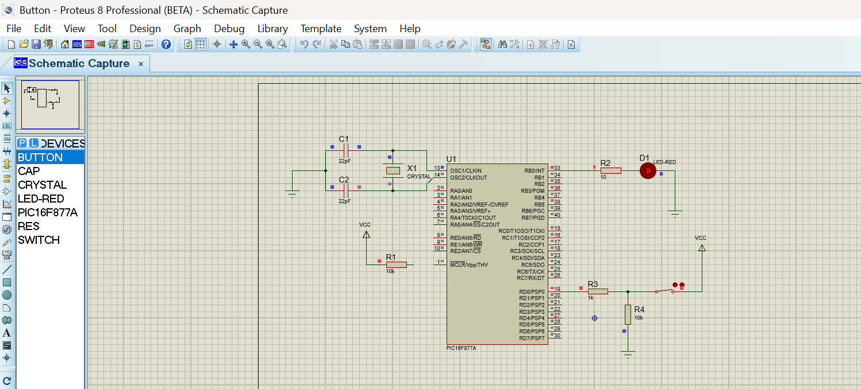

void main() {
TRISB.f0=0x00;
TRISD.f0=0xff;
portb.f0=0;
while(1)
{
if(portd.f0==1)
{
portb.f0=1;

}
else
{
portb.f0=0;

}
}
}

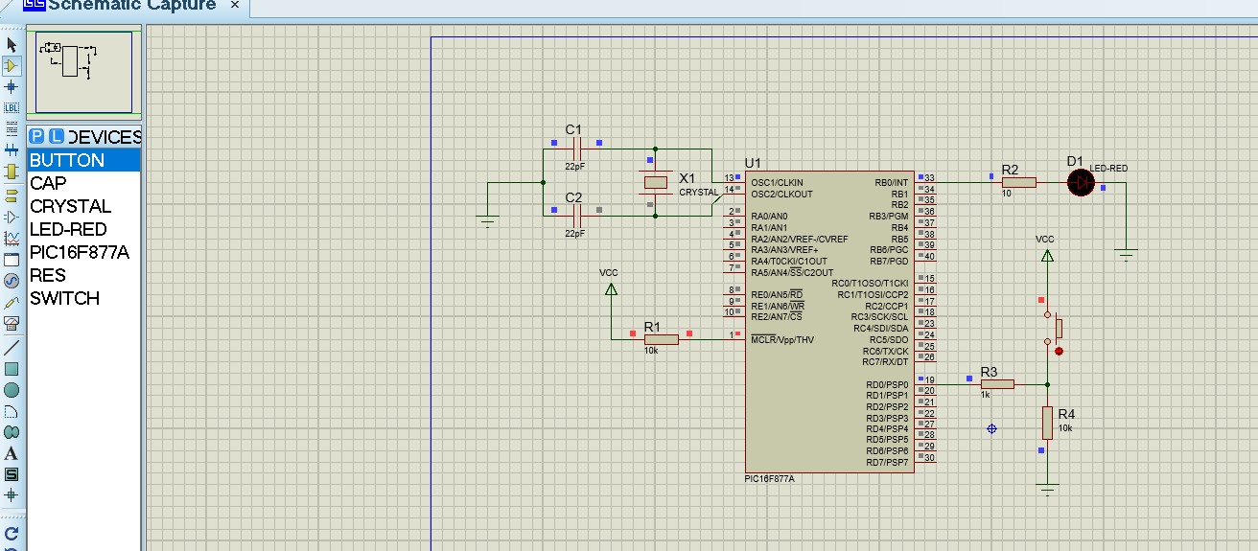

void main() {
int state=0;
TRISB.f0=0x00;
TRISD.f0=0xff;
portb.f0=0;
while(1)
{
if(portd.f0==1)
{
delay_ms(500);
if(portd.f0==1)
{
if(state==0)
state=1;
else
state=0;
}
}
if(state==0)

portb.f0=0;

else

portb.f0=1;

}

}

LAB2: Seven segment single digit CC
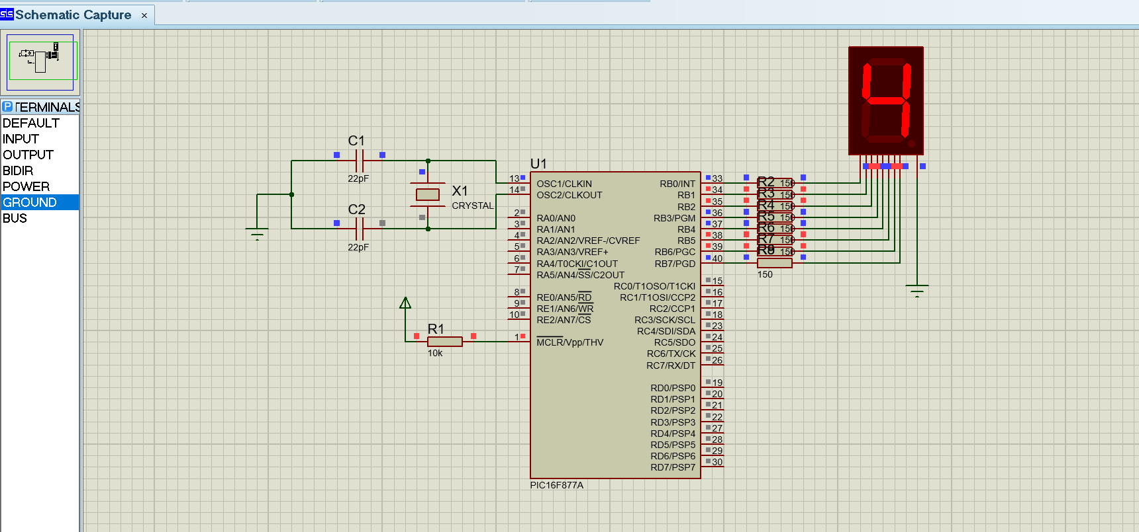

char array[]={0x3f, 0x06, 0x5b, 0x4f, 0x66, 0x6d, 0x7d, 0x07, 0x7f, 0x6f};
int i;
void main() {

TRISB=0x00;
portb=0x00;
while(1)
{
for(i=0;i<10;i++)
{
portb=array[i];
delay_ms(1000);
}
}

}

LAB3: Seven Segment with Button
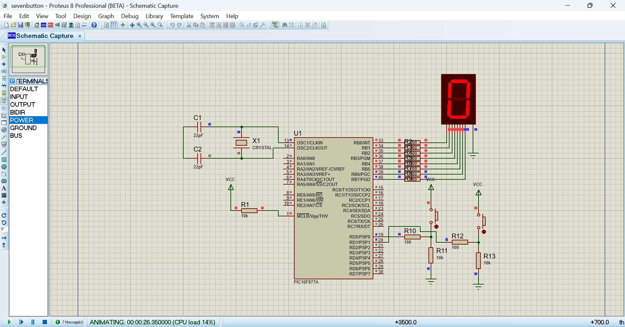
char array[]={0x3f, 0x06, 0x5b, 0x4f, 0x66, 0x6d, 0x7d, 0x07, 0x7f, 0x6f};
int i=0;

void main() {
TRISB=0x00;
TRISD=0xff;
portb=array[i];

while(1)
{
// Increment
if(portd.f0==1)
{
delay_ms(50);
if(portd.f0==1)
{
i++;
if(i>9) i=9; // max limit
portb=array[i];
while(portd.f0==1); // wait release
}
}

// Decrement
if(portd.f1==1)
{
delay_ms(50);
if(portd.f1==1)
{
i--;
if(i<0) i=0; // min limit
portb=array[i];
while(portd.f1==1); // wait release
}
}
}
}

1.4digitMultiplexer:
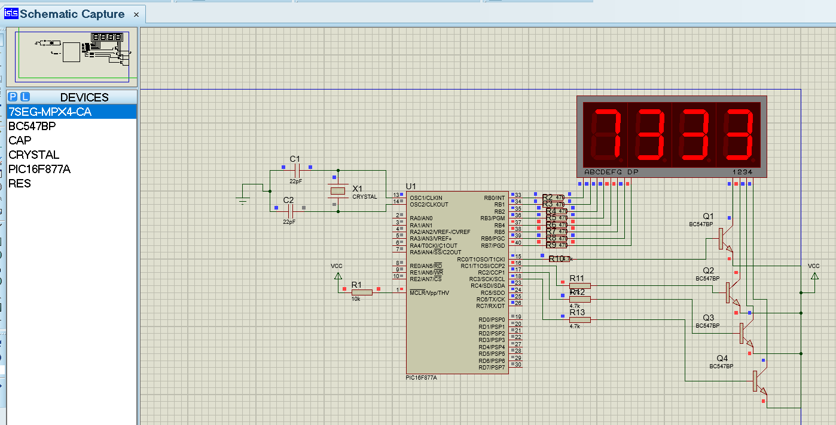

Code:
char array[] = {
0xC0, 0xF9, 0xA4, 0xB0, 0x99,
0x92, 0x82, 0xF8, 0x80, 0x90
};

void main()
{
int i;
int d1, d2, d3, d4;
int j;

TRISB = 0x00;
TRISC = 0x00;

PORTB = 0x00;
PORTC = 0x00;

while(1)
{
for(i = 7350; i >= 7300; i--)
{
d1 = i / 1000;
d2 = (i / 100) % 10;
d3 = (i / 10) % 10;
d4 = i % 10;

// 1 second display
for(j = 0; j < 80; j++)
{
// Digit 1
PORTC = 0x00;
PORTB = array[d1];
PORTC = 0x01;
Delay_ms(3);

// Digit 2
PORTC = 0x00;
PORTB = array[d2];
PORTC = 0x02;
Delay_ms(3);

// Digit 3
PORTC = 0x00;
PORTB = array[d3];
PORTC = 0x04;
Delay_ms(3);

// Digit 4
PORTC = 0x00;
PORTB = array[d4];
PORTC = 0x08;
Delay_ms(3);
}
}
}
}

Circuit:(Button and 7 segment)
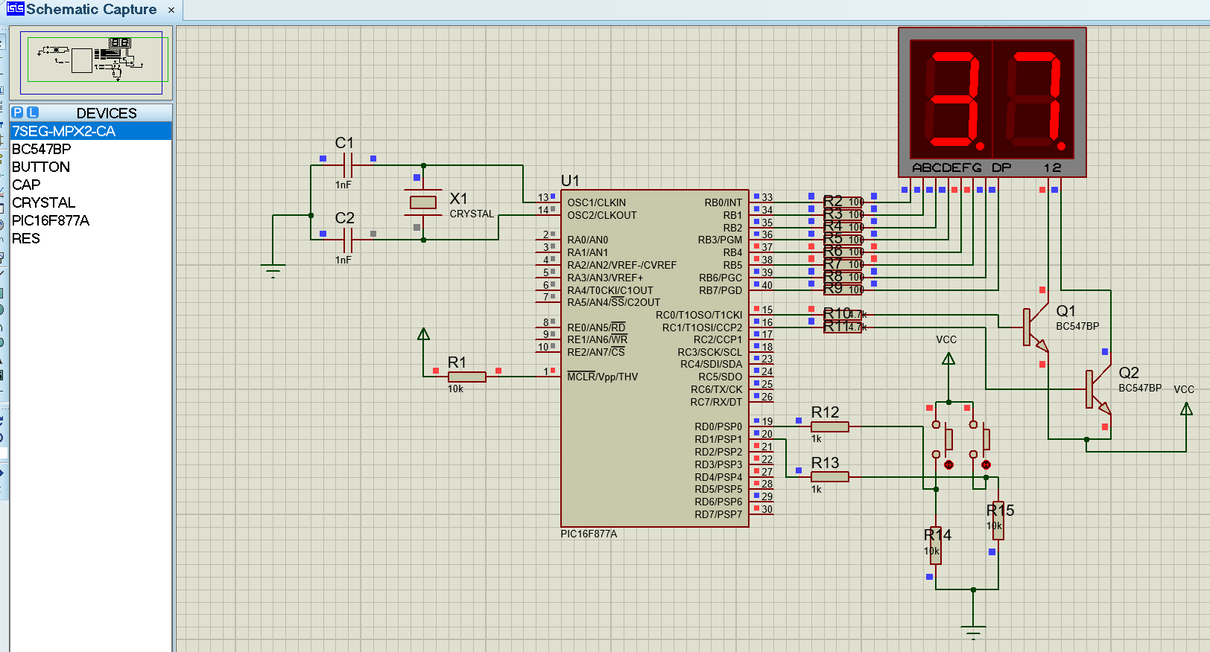
Code:
char arrayca[] = { 0x40, 0x79, 0x24, 0x30, 0x19, 0x12, 0x02, 0x78, 0x00, 0x10 }; // 0-9 segment codes
int tens,ones;
void main() {
int number = 0; // 0-99 number

// Set port direc ons
TrisB = 0x00; // PortB as output (data for 7-segment)
TrisC = 0x00; // PortC as output (digit select)
TrisD = 0x03; // PortD D0,D1 as input (bu ons)

// Ini alize ports
PortB = 0x00;
PortC = 0x00;

while (1) {
// ---- Bu on 1 pressed ? increment number ----
if (PortD.F0 == 1) {
Delay_ms(150); // Debounce
if (PortD.F0 == 1) {
number++;
if (number > 99) number = 0; // Wrap 0-99
}
}

// ---- Bu on 2 pressed ? decrement number ----
if (PortD.F1 == 1) {
Delay_ms(150); // Debounce
if (PortD.F1 == 1) {
number--;
if (number < 0) number = 99; // Wrap 0-99
}
}

// ---- Separate digits ----
tens = number / 10;
ones = number % 10;

// ---- Display tens digit ----
PortC.F0 = 1; // Enable first 7-segment
PortB = arrayca[tens];
Delay_ms(5);
PortC.F0 = 0; // Disable first 7-segment

// ---- Display ones digit ----
PortC.F1 = 1; // Enable second 7-segment
PortB = arrayca[ones];
Delay_ms(5);
PortC.F1 = 0; // Disable second 7-segment
}
}

